1.Cover Page

2. Executive Summary

3. Project Overview

4. Problem Statement

5. Objectives

6. Data Sources

7. Project Architecture

8. ETL Pipeline Design

9. Data Cleaning & Preprocessing

10. Database Design (SQLite)

11. Exploratory Data Analysis

12. Performance Analytics

13. Advanced Analytics & Risk Metrics

14. Power BI Dashboard

15. Key Findings

16. Limitations

17. Recommendations

18. Conclusion

19. References

BLUESTOCK FINTECH

MUTUAL FUND ANALYTICS CAPSTONE PROJECT
Prepared By:- mandavajyothi47
Internship Project
Submission Date: June 2026
Project Duration: Day 1 – Day 7
Tools & Technologies Used:
• Python
• Pandas
• NumPy
• SQLite
• Power BI
• Git & GitHub
• Jupyter Notebook

This project presents a comprehensive Mutual Fund Analytics platform developed as part of the Bluestock Internship Capstone Project. The objective of the project was to build an end-to-end analytics solution capable of collecting, processing, analyzing, and visualizing mutual fund data to support investment decision-making.
The project integrates multiple stages including data collection, data cleaning, database management, exploratory data analysis, performance analytics, advanced risk analysis, and interactive dashboard development. Historical Net Asset Value (NAV) data for multiple mutual fund schemes was processed and analyzed using Python-based analytical workflows.
Performance metrics such as CAGR, Sharpe Ratio, Sortino Ratio, Alpha, Beta, Maximum Drawdown, Value at Risk (VaR), Conditional Value at Risk (CVaR), and Rolling Sharpe Ratio were calculated to evaluate fund performance and risk-adjusted returns. Investor transaction data was analyzed to understand cohort behaviour and SIP continuity patterns.
A Power BI dashboard was developed to provide business-friendly visualizations for industry trends, fund performance, investor behaviour, and SIP analytics. The final solution demonstrates the practical application of data analytics, financial analysis, and business intelligence techniques within the mutual fund domain.

PROJECT OVERVIEW
The Bluestock Mutual Fund Analytics Capstone Project was developed to create a comprehensive analytics platform for evaluating mutual fund performance, investor behaviour, portfolio composition, and market trends. The project combines data engineering, financial analytics, risk analysis, and business intelligence techniques to transform raw mutual fund datasets into meaningful insights.
The solution follows an end-to-end workflow beginning with data collection and preprocessing, followed by data storage, exploratory analysis, performance evaluation, advanced risk analytics, and dashboard visualization. Multiple datasets including mutual fund master information, NAV history, investor transactions, SIP inflows, benchmark indices, and portfolio holdings were integrated into a unified analytical framework.
The project was implemented using Python, Pandas, NumPy, SQLite, Jupyter Notebook, Power BI, and GitHub. The final outcome is an analytics system capable of helping investors and analysts understand fund performance, risk characteristics, investor trends, and portfolio diversification patterns.

PROBLEM STATEMENT
The mutual fund industry generates large volumes of financial and transactional data. Investors often face difficulties in evaluating mutual funds due to the complexity of performance metrics, risk measures, benchmark comparisons, and portfolio compositions.
Traditional reports provide limited visibility into fund performance and investor behaviour. There is a need for a centralized analytics solution capable of processing historical fund data, calculating performance and risk metrics, analyzing investor activity, and presenting insights through interactive dashboards.
The primary challenge addressed in this project is the transformation of raw mutual fund datasets into actionable business insights that support informed investment decisions.

OBJECTIVES
- Build a structured mutual fund analytics database using cleaned and validated datasets.
- Perform exploratory data analysis to understand fund characteristics, investor demographics, and market trends.
- Calculate key performance indicators including CAGR, Sharpe Ratio, Sortino Ratio, Alpha, Beta, and Maximum Drawdown.
- Compare mutual fund performance against benchmark indices.
- Analyze investor transaction patterns, SIP behaviour, and cohort characteristics.
- Compute advanced risk measures including Value at Risk (VaR), Conditional Value at Risk (CVaR), and Rolling Sharpe Ratio.
- Develop a simple fund recommendation system based on risk-adjusted performance metrics.
- Design an interactive Power BI dashboard for business users and decision makers.
- Generate actionable insights and recommendations based on analytical findings.
- Demonstrate the practical application of financial analytics, data engineering, and business intelligence techniques within the mutual fund domain.

DATA SOURCES
The Bluestock Mutual Fund Analytics project was built using ten datasets covering mutual fund performance, investor activity, industry trends, benchmark tracking, and portfolio composition.
The datasets used are:
- Fund Master Dataset (01_fund_master)
  - Scheme information
  - Fund house details
  - Category and sub-category information
  - Risk classifications
- NAV History Dataset (02_nav_history)
  - Historical Net Asset Value (NAV) records
  - Daily fund performance tracking
- AUM by Fund House Dataset (03_aum_by_fund_house)
  - Assets Under Management (AUM)
  - Fund house market share analysis
- Monthly SIP Inflows Dataset (04_monthly_sip_inflows)
  - Monthly SIP contributions
  - SIP growth trends
- Category Inflows Dataset (05_category_inflows)
  - Category-wise investment inflows
  - Industry investment trends
- Industry Folio Count Dataset (06_industry_folio_count)
  - Investor folio statistics
  - Industry participation trends
- Scheme Performance Dataset (07_scheme_performance)
  - Fund return metrics
  - Performance evaluation indicators
- Investor Transactions Dataset (08_investor_transactions)
  - SIP transactions
  - Lump sum investments
  - Redemption records
  - Investor demographics
- Portfolio Holdings Dataset (09_portfolio_holdings)
  - Stock holdings
  - Sector allocation details
  - Portfolio concentration analysis
- Benchmark Indices Dataset (10_benchmark_indices)
  - Benchmark index performance
  - Comparative performance analysis
These datasets were integrated through a unified ETL pipeline and subsequently used for exploratory analysis, performance measurement, risk assessment, investor analytics, and dashboard development.

PROJECT ARCHITECTURE
The project follows a layered analytics architecture consisting of data ingestion, processing, storage, analysis, and visualization stages.
Workflow:
Raw CSV Data
↓
Data Cleaning & Validation
↓
Feature Engineering
↓
SQLite Database Storage
↓
Exploratory Data Analysis
↓
Performance Analytics
↓
Advanced Risk Analytics
↓
Power BI Dashboard
↓
Business Insights & Recommendations
This architecture ensures data consistency, scalability, and efficient analytical processing across multiple datasets.

ETL PIPELINE DESIGN
An Extract-Transform-Load (ETL) pipeline was developed to automate data preparation and improve data quality.
Extract Phase
Raw datasets were collected from multiple CSV sources including mutual fund performance data, investor transactions, benchmark indices, and portfolio holdings.
Transform Phase
Several preprocessing operations were performed:
• Missing value handling
• Duplicate record removal
• Data type conversion
• Date formatting
• Feature engineering
• Return calculations
• Risk metric preparation
• Data validation checks
Load Phase
The cleaned datasets were stored in SQLite and exported as processed CSV files for further analysis and dashboard integration.
Benefits of the ETL Pipeline:
• Improved data quality
• Standardized formats
• Reduced manual processing
• Faster analytics execution
• Better dashboard performance
The ETL pipeline serves as the foundation for all subsequent analytical tasks performed within the project.

DATA CLEANING AND PREPROCESSING
Data quality is a critical factor in financial analytics. Before performing any analysis, all datasets underwent a systematic cleaning and preprocessing process to ensure consistency, accuracy, and reliability.
The following operations were performed:
• Removal of duplicate records
• Identification and handling of missing values
• Standardization of column names
• Conversion of date fields into datetime format
• Validation of numerical fields
• Data type corrections
• Feature engineering for return calculations
• Consistency checks across datasets
For NAV data, daily returns were calculated to support performance and risk analytics. Investor transaction data was standardized to enable cohort analysis and SIP continuity analysis. Portfolio holdings data was validated to ensure accurate sector allocation and concentration calculations.
The preprocessing stage significantly improved data quality and enabled efficient downstream analytics.

DATABASE DESIGN
To improve data organization and analytical efficiency, cleaned datasets were stored in a structured format for further processing and reporting.
The project utilized multiple cleaned datasets representing different business entities, including:
• Fund Master
• NAV History
• AUM by Fund House
• Monthly SIP Inflows
• Category Inflows
• Industry Folio Count
• Scheme Performance
• Investor Transactions
• Portfolio Holdings
• Benchmark Indices
Relationships between datasets were maintained through common identifiers such as AMFI Code, dates, and fund categories. This design enabled efficient data integration and simplified analytical workflows.
The structured data architecture provided a reliable foundation for exploratory analysis, performance measurement, risk analytics, and dashboard visualization.

EXPLORATORY DATA ANALYSIS (EDA)
Exploratory Data Analysis was conducted to understand fund characteristics, investor demographics, portfolio structures, and industry trends.
Several visualization techniques were used to uncover meaningful patterns and relationships within the datasets.
Key analyses performed included:
• Assets Under Management (AUM) distribution across fund houses
• Monthly SIP growth trends
• Category-wise inflow analysis
• Investor age group distribution
• Gender distribution analysis
• State-wise investor participation
• Correlation analysis among financial variables
• Portfolio sector allocation analysis
The EDA process revealed significant variations in fund size, investor behaviour, and portfolio diversification patterns. These findings provided the foundation for subsequent performance and risk analytics.

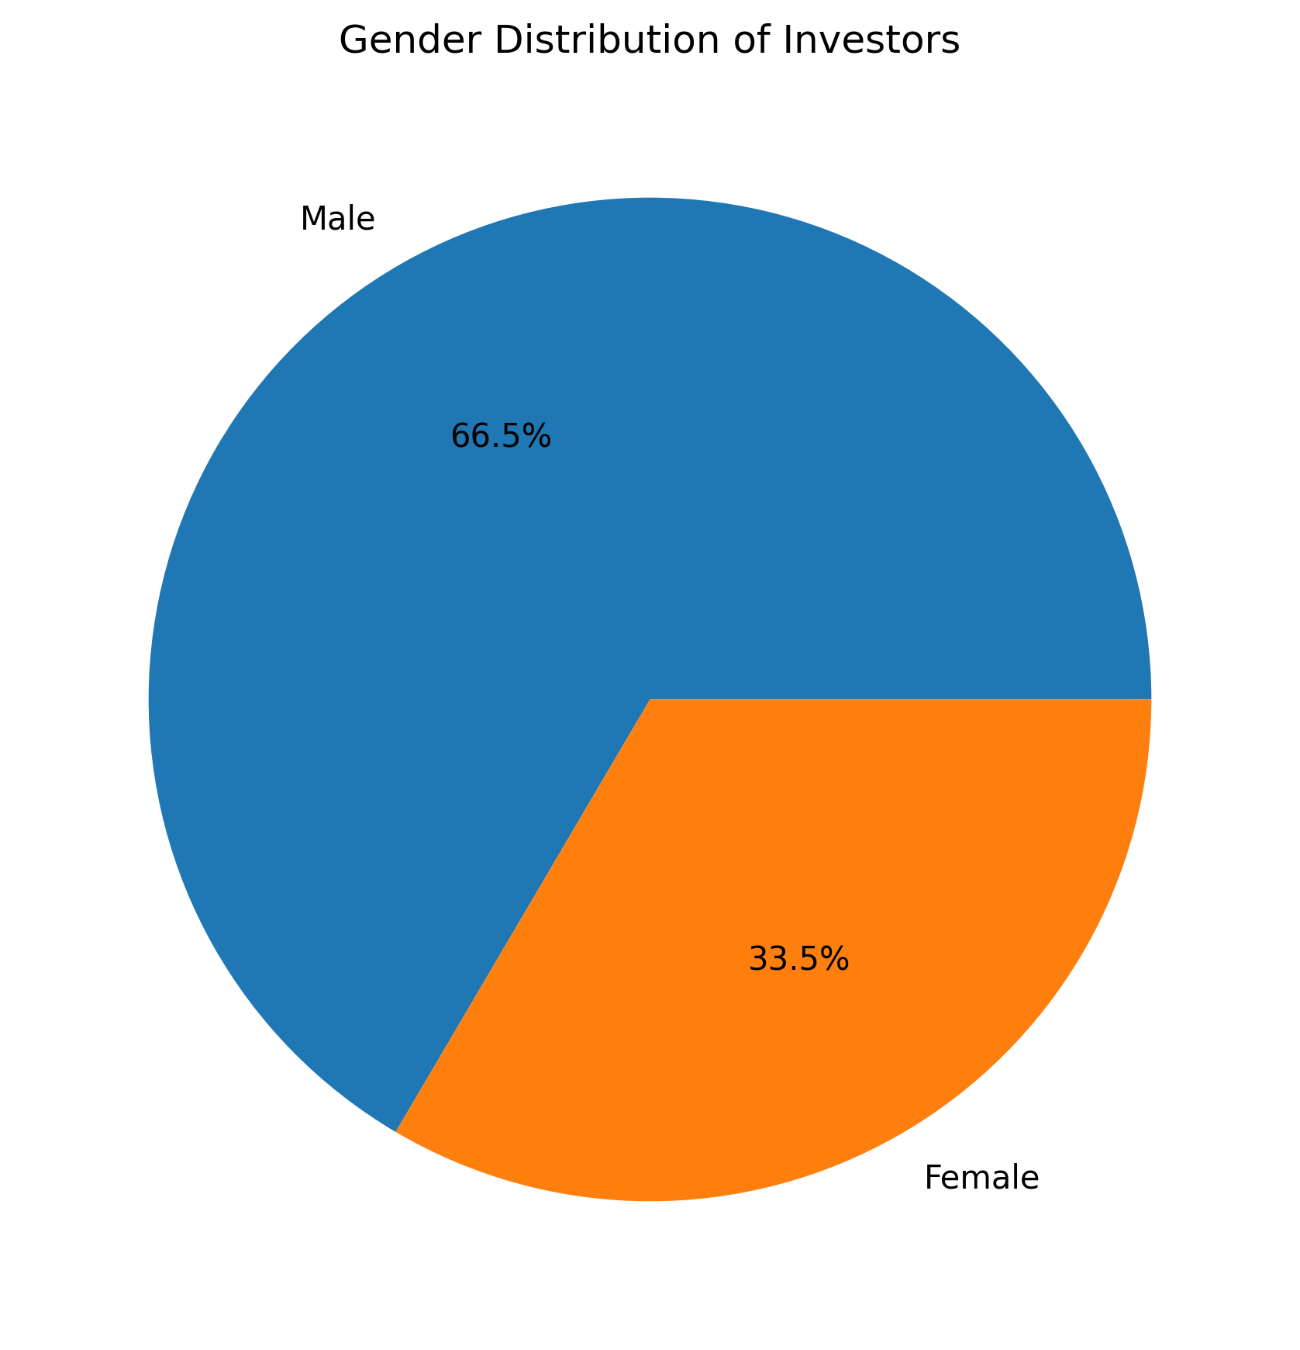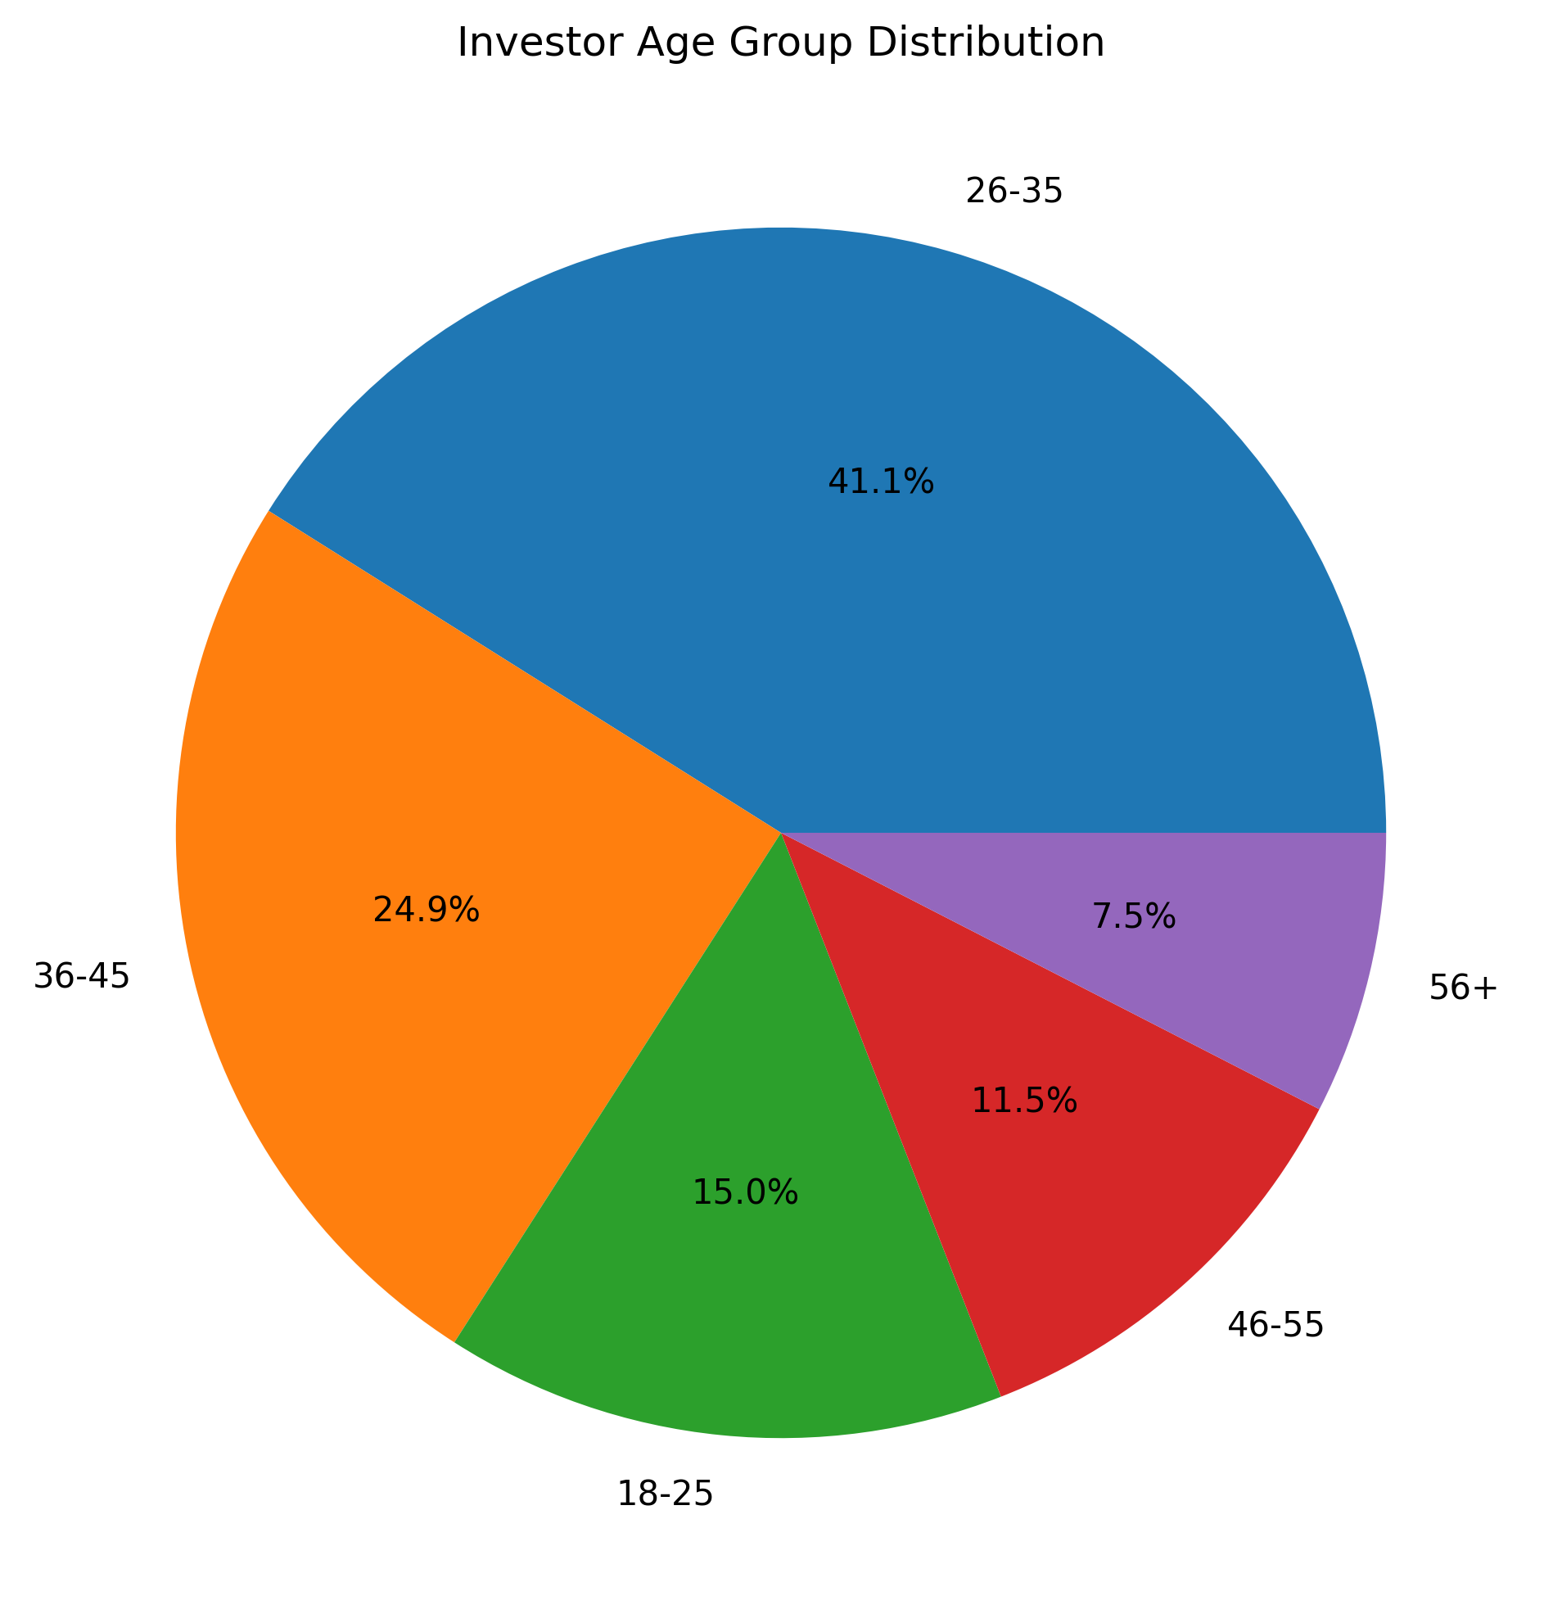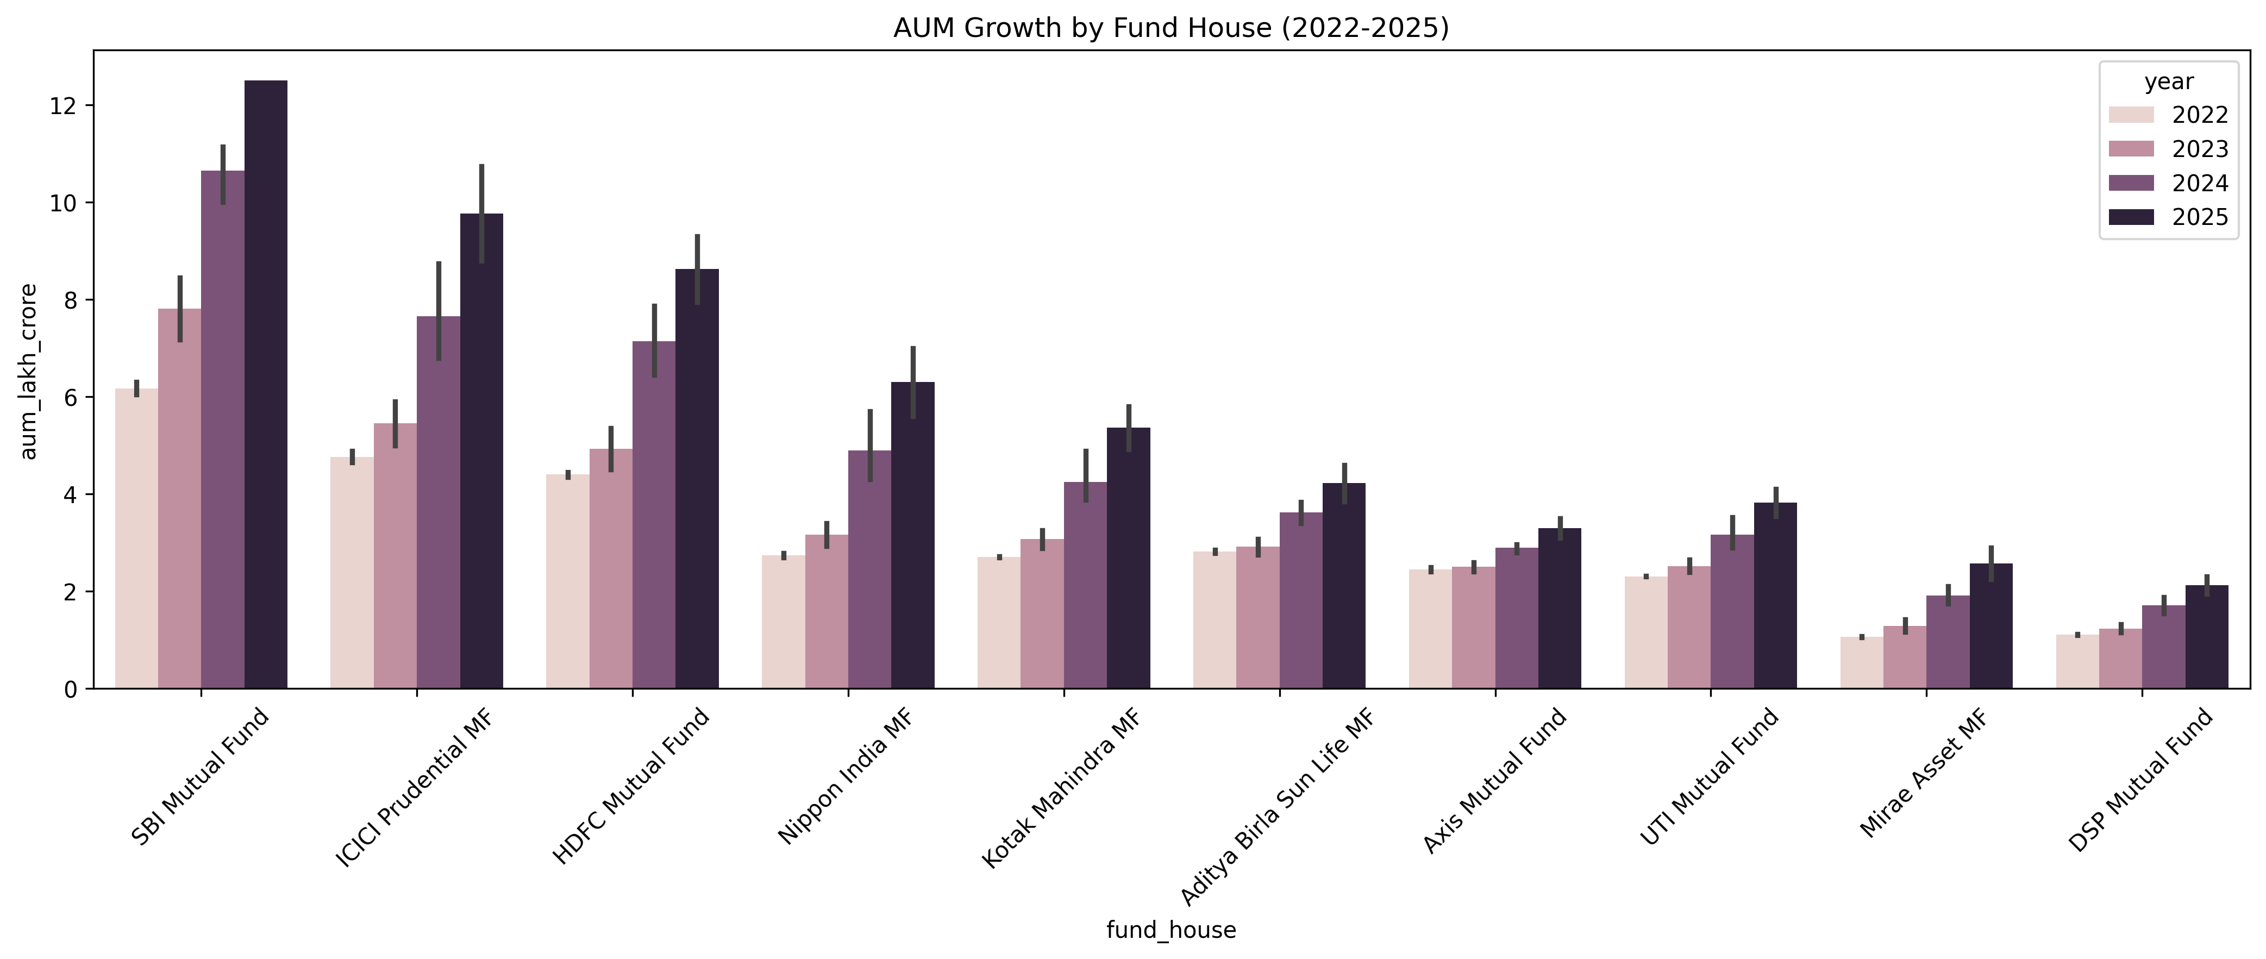

PERFORMANCE ANALYTICS
The performance of mutual fund schemes was evaluated using multiple return and risk-adjusted performance metrics. These metrics provide a comprehensive understanding of fund performance beyond simple returns.
The key metrics calculated include:
- Compound Annual Growth Rate (CAGR)
  - Measures annualized growth over the investment period.
- Sharpe Ratio
  - Measures return generated per unit of total risk.
- Sortino Ratio
  - Measures return generated per unit of downside risk.
- Alpha
  - Indicates excess return generated relative to the benchmark.
- Beta
  - Measures sensitivity of a fund relative to market movements.
- Maximum Drawdown
  - Measures the largest peak-to-trough decline experienced by a fund.
Benchmark comparisons were also performed to evaluate whether funds outperformed or underperformed market indices over time.
These metrics enabled the identification of funds delivering superior risk-adjusted performance.

ADVANCED RISK ANALYTICS
In addition to traditional performance metrics, advanced risk measures were calculated to assess downside risk and portfolio concentration.
Value at Risk (VaR)
Historical Value at Risk at a 95% confidence level was calculated using daily return distributions. VaR estimates the maximum expected loss under normal market conditions over a specified period.
Conditional Value at Risk (CVaR)
CVaR was computed as the average loss beyond the VaR threshold. This metric provides a more comprehensive measure of tail risk by considering extreme adverse outcomes.
Rolling Sharpe Ratio
A 90-day rolling Sharpe Ratio was calculated for selected mutual fund schemes. This analysis provided insight into how risk-adjusted performance changed over time under different market conditions.
Investor Cohort Analysis
Investors were grouped based on their first investment year. Cohort analysis was used to evaluate investment behaviour, average investment size, and long-term participation patterns.
SIP Continuity Analysis
Investors with six or more SIP transactions were analyzed to determine investment consistency. Investors with average gaps greater than 35 days between SIP transactions were categorized as At-Risk.
Sector Concentration Analysis
Portfolio concentration was evaluated using the Herfindahl-Hirschman Index (HHI). Higher HHI values indicate greater concentration within a limited number of holdings, while lower values suggest better diversification.

KEY RISK FINDINGS
- Small-cap mutual funds exhibited the highest Value at Risk (VaR) and Conditional Value at Risk (CVaR), indicating greater downside risk during adverse market conditions.
- Rolling Sharpe Ratio analysis demonstrated that risk-adjusted performance varied significantly across market cycles.
- Investor cohort analysis revealed that the 2024 cohort contributed the largest investment volume and accounted for the majority of active investors.
- SIP continuity analysis identified a substantial number of investors categorized as At-Risk due to irregular investment intervals.
- Sector concentration analysis showed that certain schemes maintained highly concentrated portfolios, resulting in elevated HHI values and increased concentration risk.
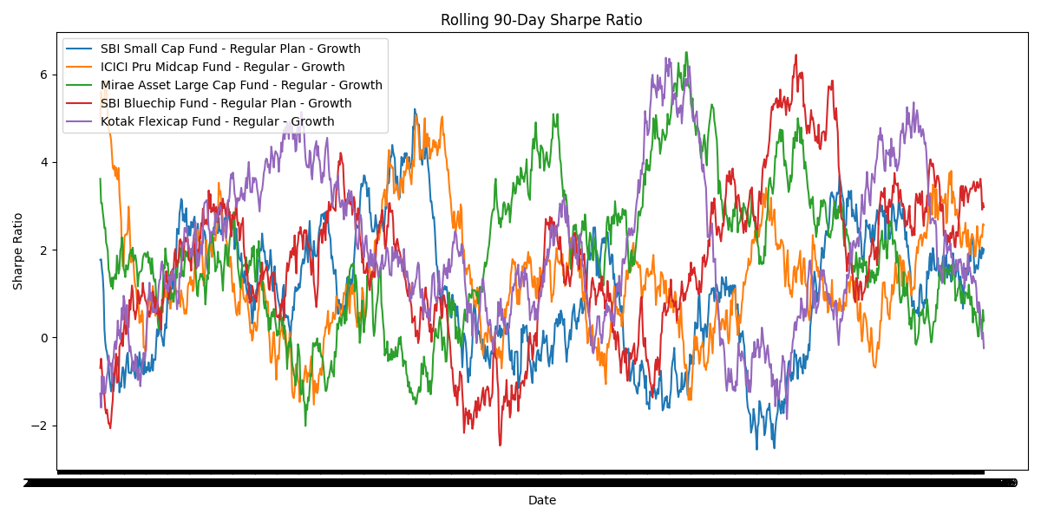
Table 1: Top Funds by VaR and CVaR
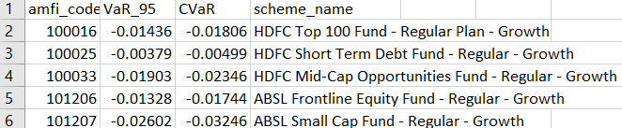

Table 2: Highest Portfolio Concentration (HHI)

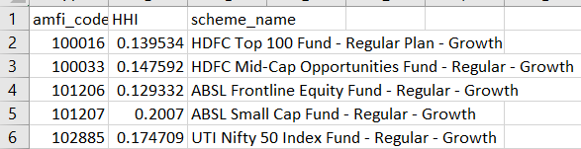

POWER BI DASHBOARD
An interactive Power BI dashboard was developed to transform analytical results into business-friendly visualizations. The dashboard provides decision-makers with a centralized platform for monitoring mutual fund performance, investor behaviour, industry trends, and risk indicators.
The dashboard consists of four major analytical views:
- Industry Overview
  - Assets Under Management (AUM) analysis
  - Fund house comparison
  - Industry-level growth trends
- Fund Performance
  - Scheme performance metrics
  - Benchmark comparisons
  - Risk-adjusted performance indicators
- Investor Analytics
  - Investor demographics
  - Age group analysis
  - Geographic distribution
  - Transaction behaviour
- SIP & Market Trends
  - SIP growth patterns
  - Category inflows
  - Market participation trends
Interactive filters and drill-down capabilities allow users to explore data at multiple levels of detail.
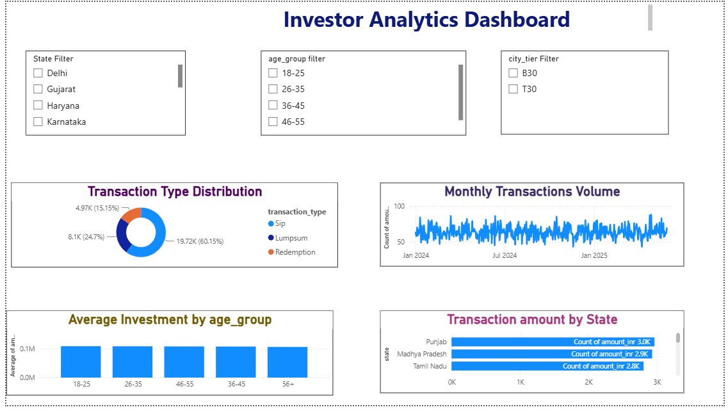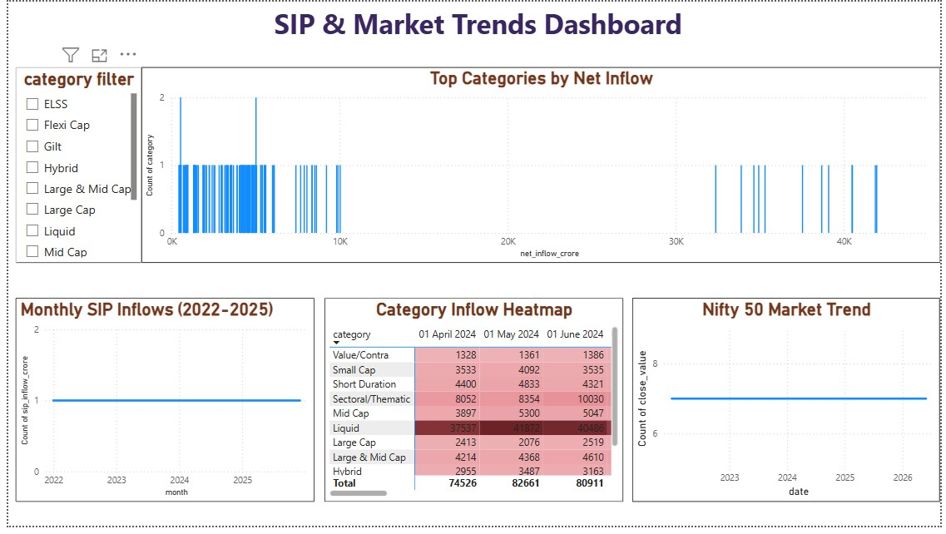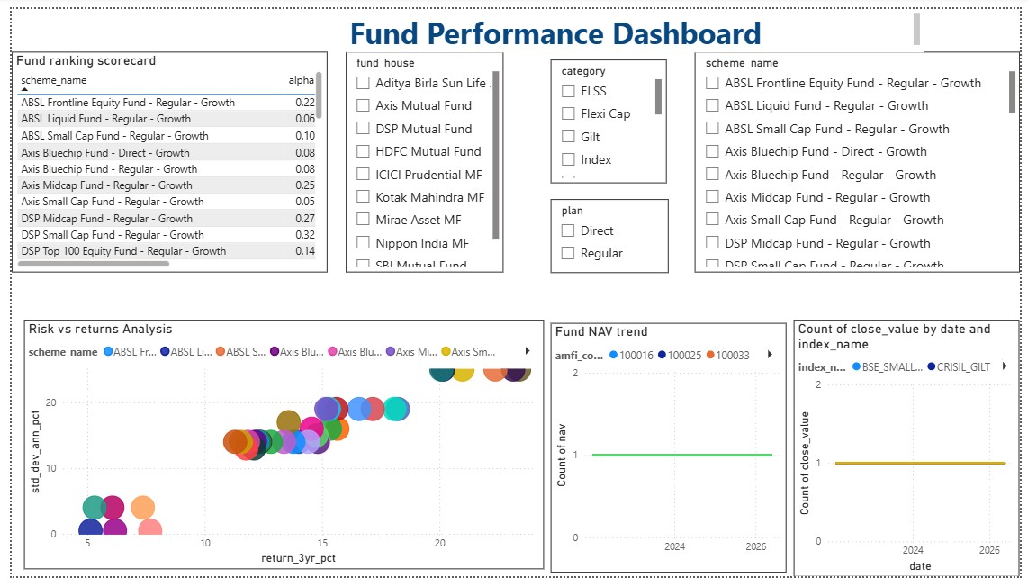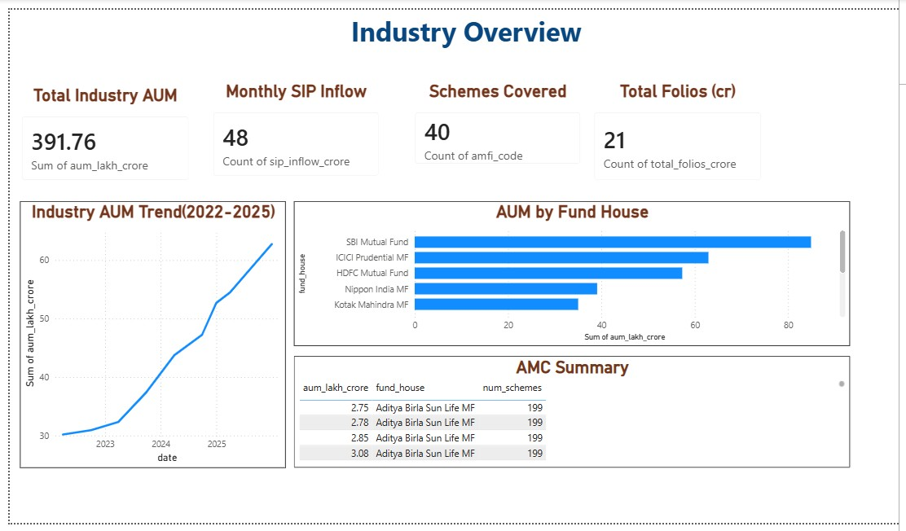

KEY FINDINGS
- SBI, ICICI Prudential, and HDFC emerged among the largest fund houses based on Assets Under Management.
- Small-cap funds generated higher returns but also exhibited significantly higher risk levels, as reflected in VaR and CVaR metrics.
- Risk-adjusted performance varied substantially across schemes, highlighting the importance of evaluating returns alongside risk measures.
- Investor activity was concentrated within a limited number of states and urban regions.
- SIP investments demonstrated strong participation and remained one of the primary investment modes among retail investors.
- Cohort analysis indicated that investors entering in 2024 accounted for the highest overall investment volume.
- Portfolio concentration analysis identified several schemes with elevated HHI values, suggesting reduced diversification.
- Benchmark comparisons revealed that some actively managed funds consistently outperformed market indices while others closely tracked benchmark performance.

CONCLUSION

CONCLUSION

The Bluestock Mutual Fund Analytics Capstone Project successfully demonstrated the application of data analytics, financial modeling, and business intelligence techniques within the mutual fund industry.
The project transformed raw financial datasets into meaningful insights through a structured workflow involving ETL processing, exploratory analysis, performance evaluation, advanced risk analytics, and dashboard visualization.
By integrating Python, SQLite, Power BI, and GitHub-based project management practices, a scalable analytics solution was developed that supports investment analysis and business decision-making.
The resulting platform provides valuable insights into fund performance, investor behaviour, portfolio composition, and industry trends. The project highlights the importance of combining analytical rigor with visualization techniques to support data-driven financial decision-making.

